 |  | Mathematics Essentials 2015  Test 4  Task Weighting: 5%
Student Name:

Time Allowed: 45 Minutes Total Marks: 40

Calculators and files are allowed in this test.
Answer all of the following questions. Show all working to maximise marks.

Question 1 [8 Marks]

Complete the missing values to make the conversions true
.
- 6 kilograms = grams

- 5 tonnes = kilograms

- 40 cm³ = mm³

- 3 m³ = cm³

(e) 70000 cm³ = m³

(f) 5000 watts = kW

(g) 0.812 kW = watts

(h) 5400 joules = kilojoules

Question 2 [2 Marks]

Joe makes coffees in a coffee shop. He uses one-fifth of a litre of milk to make one chocolate latte. There are only 6 L of milk left. How many chocolate lattes can he make?

Question 3 [2 Marks]

Harry is fixing the driveway to his property. He needs 0·75 tonnes of blue metal that costs $82 per tonne. How much will the blue metal Harry requires cost?

Question 4 [3 Marks: 1, 2]

Calculate the volume of each of these prisms by counting the cubes.

(a) | 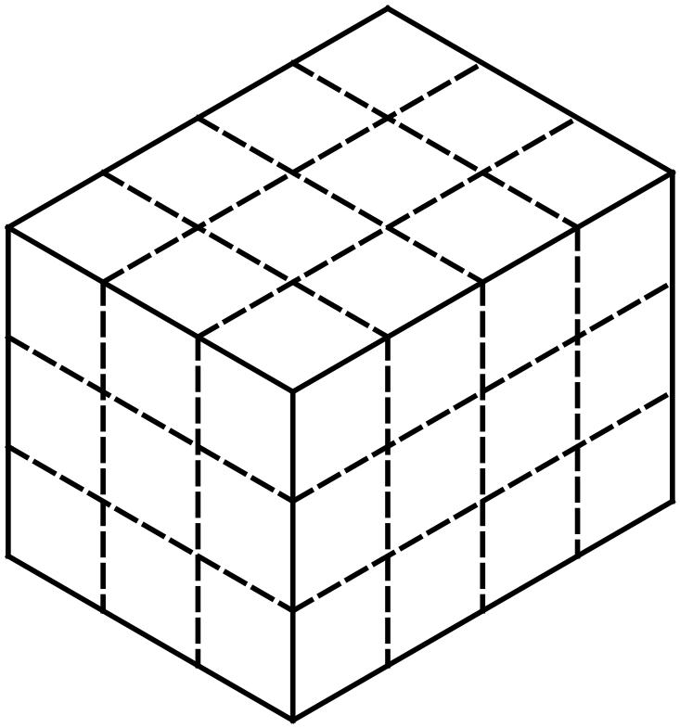 | (b) | 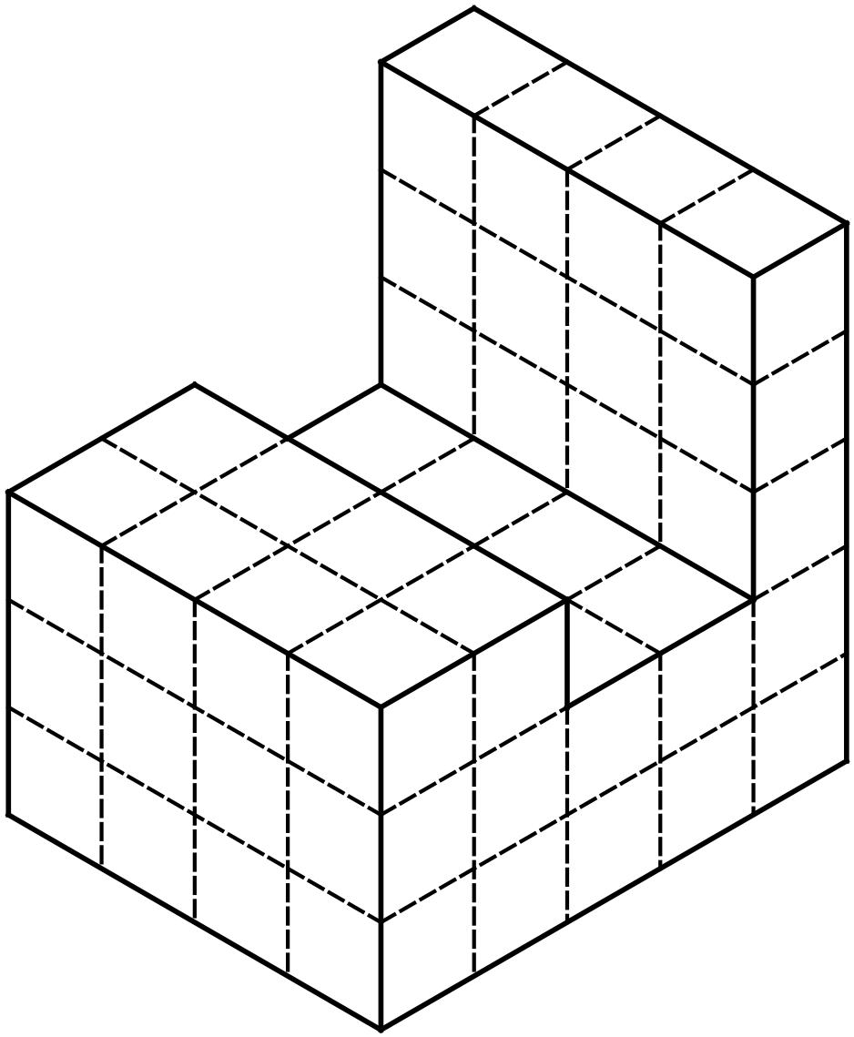

Question 5 [5 Marks: 1, 1, 1, 2]

A clothes dryer is rated at 2350 watts and is used for about half an hour each morning during winter.

a) Convert 2350 watts to kilowatts

b) How many hours is the dryer used each week?

c) What is the total number of kilowatt hours used by the dryer in one week.

(d) At 23.8 cents per kWh, how much will it cost to run the dryer in one week.

Question 6 [2 marks]

Calculate the volume of this dice if each face (flat surface) is 2 cm by 2 cm.

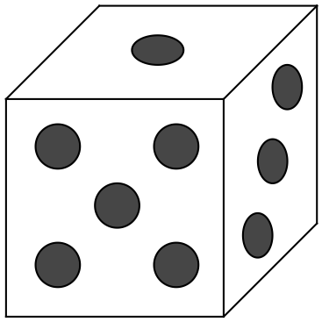

Question 7 [6 Marks: 2, 2, 2]

Calculate the volume of these prisms showing all your working.

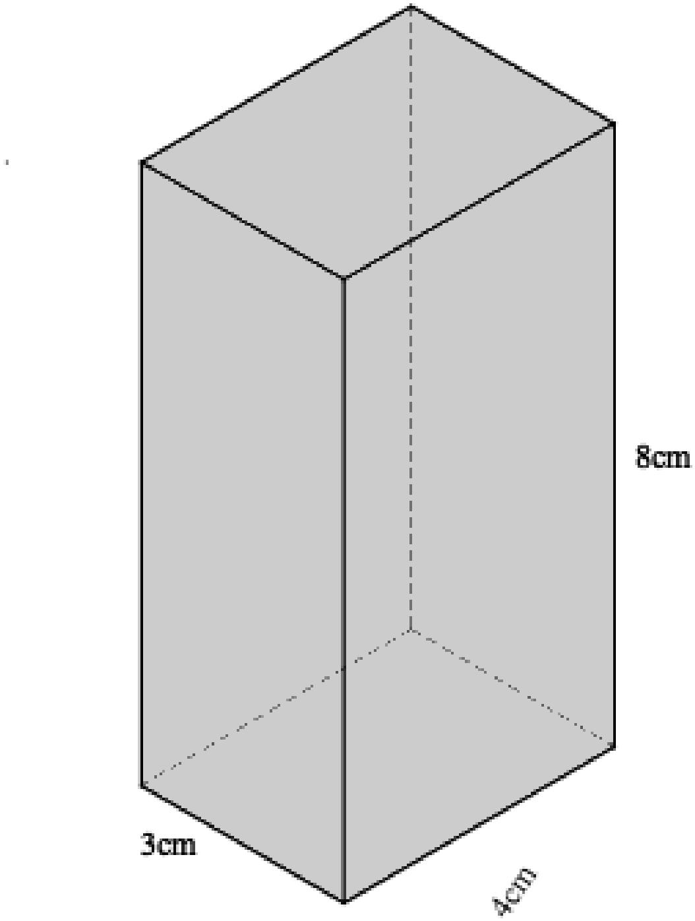
a) b)

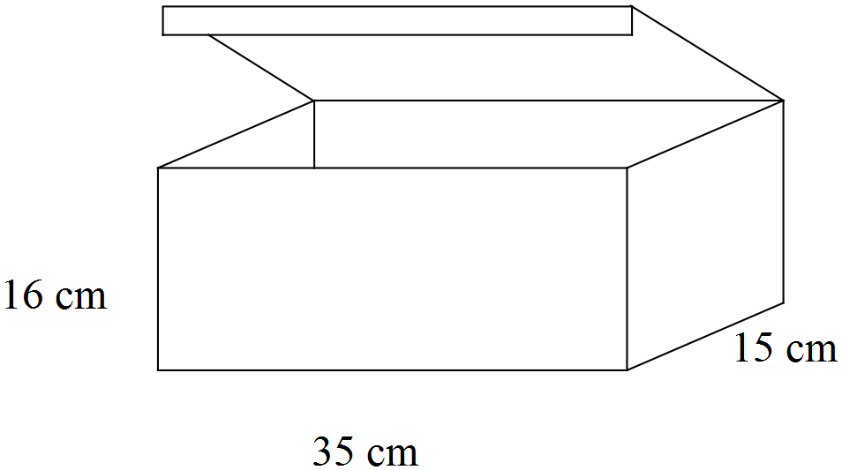

c)
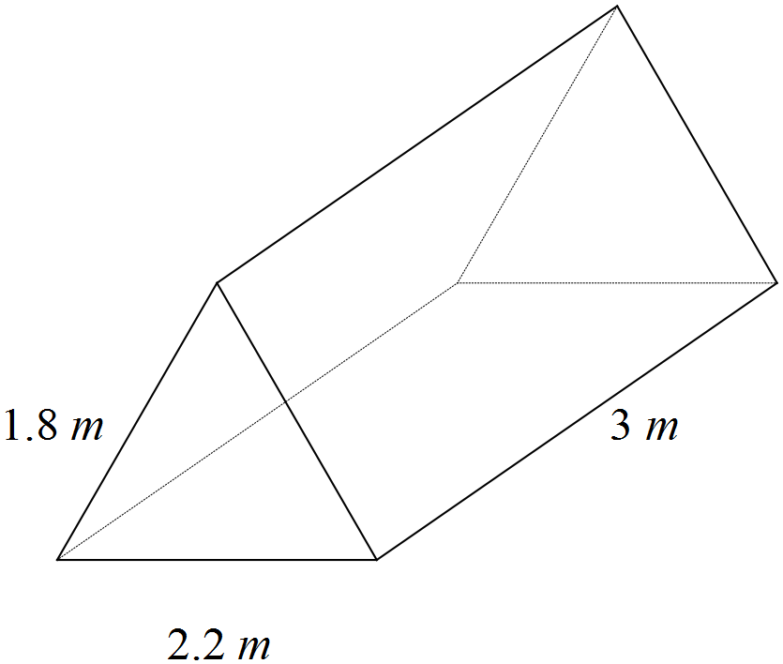

Question 8 [6 Marks: 2, 2, 2]

Recipes often measure liquid in cups and teaspoons. I cup = 250 ml and
1 teaspoon = 5 ml

a) How many cups in 5 Litres?

b) How many teaspoons in a cup?

c) What fraction of a litre is a teaspoon? Write your answer in simplest form.

Question 9 [4 Marks]

Skim milk contains 162 kJ per 100 ml whereas full cream milk contains 270 kJ per 100 ml. NOTE: 1 calorie = 4.184 and 1 kJ = 0.239 calories

How many more calories are there in a cup of full cream milk than a cup of skim milk?

Question 10 [2 marks]

a) A car’s rectangular prism shaped fuel tank has dimensions of 670 mm by
605 mm by 210 mm. What is it’s capacity to the nearest litre?

b) The actual capacity of fuel tank can vary by as much as 3% of the stated capacity. Using your answer from part a) calculate the maximum and minimum capacity possible with a 3% variation.

c) On many bikes and cars the fuel light comes on when the tank is at 15% of the capacity or less. How much fuel remains when the fuel light comes on in this vehicle?

END OF TEST

